**Cloud Computing**

**What is cloud?**

"The cloud" refers to servers that are accessed over the Internet, and the software and databases that run on those servers. Cloud servers are located in datacenters all over the world. By using cloud computing, users and companies don't have to manage physical servers themselves or run software applications on their own machines.

Cloud computing can be visualised as below

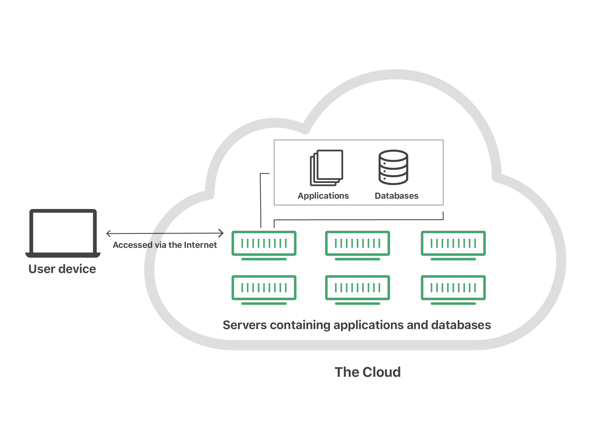

For businesses, switching to cloud computing removes some IT costs and overhead: for instance, they no longer need to update and maintain their own servers, as the cloud vendor they are using will do that. This especially makes an impact for small businesses that may not have been able to afford their own internal infrastructure but can outsource their infrastructure needs affordably via the cloud. The cloud can also make it easier for companies to operate internationally, because employees and customers can access the same files and applications from any location.

Cloud has the ability to provide a developer or a user, the best computing power he needs for his applications to run one time or multiple instances without actually bearing the high cost of those machines.

**How does cloud computing work?**

Cloud computing is possible because of a technology called virtualization. Virtualization allows for the creation of a simulated, digital-only "virtual" computer that behaves as if it were a physical computer with its own hardware. The technical term for such a computer is virtual machine. When properly implemented, virtual machines on the same host machine are sandboxed from one another, so they don't interact with each other at all, and the files and applications from one virtual machine aren't visible to the other virtual machines even though they're on the same physical machine.

Virtual machines also make more efficient use of the hardware hosting them. By running many virtual machines at once, one server becomes many servers, and a datacenter becomes a whole host of datacenters, able to serve many organizations. Thus, cloud providers can offer the use of their servers to far more customers at once than they would be able to otherwise, and they can do so at a low cost.

**Various Service Models Of Cloud Computing:**

1. SaaS
2. PaaS
3. IaaS

**Software-as-a-Service (SaaS):** Instead of users installing an application on their device, SaaS applications are hosted on cloud servers, and users access them over the Internet. SaaS is like renting a house: the landlord maintains the house, but the tenant mostly gets to use it as if they owned it. Examples of SaaS applications include Salesforce, MailChimp, and Slack.

**Platform-as-a-Service (PaaS):** In this model, companies don't pay for hosted applications; instead they pay for the things they need to build their own applications. PaaS vendors offer everything necessary for building an application, including development tools, infrastructure, and operating systems, over the Internet. PaaS can be compared to renting all the tools and equipment necessary for building a house, instead of renting the house itself. PaaS examples include AWS, Microsoft Azure, etc.

**Infrastructure-as-a-Service (IaaS):** In this model, a company rents the servers and storage they need from a cloud provider. They then use that cloud infrastructure to build their applications. IaaS is like a company leasing a plot of land on which they can build whatever they want – but they need to provide their own building equipment and materials. IaaS providers include AWS, Google Compute Engine, and OpenStack.

**Advantages Of Cloud Computing:**

Cost Savings

Cost saving is the biggest benefit of cloud computing. It helps you to save substantial capital cost as it does not need any physical hardware investments. Also, you do not need trained personnel to maintain the hardware. The buying and managing of equipment is done by the cloud service provider.

Strategic edge

Cloud computing offers a competitive edge over your competitors. It helps you to access the latest and applications any time without spending your time and money on installations.

High Speed

Cloud computing allows you to deploy your service quickly in fewer clicks. This faster deployment allows you to get the resources required for your system within fewer minutes.

Back-up and restore data

Once the data is stored in a Cloud, it is easier to get the back-up and recovery of that, which is otherwise very time taking process on-premise.

Automatic Software Integration

In the cloud, software integration is something that occurs automatically. Therefore, you don't need to take additional efforts to customize and integrate your applications as per your preferences.

Reliability

Reliability is one of the biggest pluses of cloud computing. You can always get instantly updated about the changes.

Mobility

Employees who are working on the premises or at the remote locations can easily access all the could services. All they need is an Internet connectivity.

Unlimited storage capacity

The cloud offers almost limitless storage capacity. At any time you can quickly expand your storage capacity with very nominal monthly fees.

Collaboration

The cloud computing platform helps employees who are located in different geographies to collaborate in a highly convenient and secure manner.

Quick Deployment

Last but not least, cloud computing gives you the advantage of rapid deployment. So, when you decide to use the cloud, your entire system can be fully functional in very few minutes. Although, the amount of time taken depends on what kind of technologies are used in your business.

**Apart from the above, some other advantages of cloud computing are:**

* On-Demand Self-service
* Allows pay on demand
* Offers Resilient Computing
* Fast and effective virtualization
* Provide you low-cost software
* Offers advanced online security
* Location and Device Independence
* Always available, and scales automatically to adjust to the increase in demand
* Web-based control & interfaces
* API Access available.

**References :**

* <https://www.cloudflare.com/learning/cloud/what-is-the-cloud/>
* <https://www.guru99.com/advantages-disadvantages-cloud-computing.html>